**Technology Innovation Management**

**Technology Adoption Cycle**

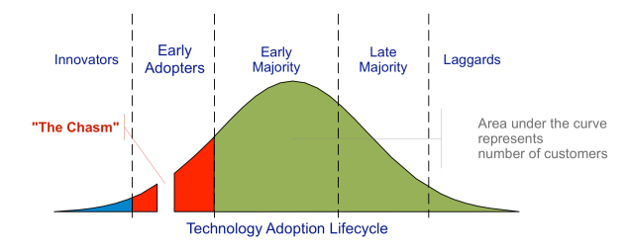\

Before you cross the chasm you need to get to the chasm. And these days a lot of companies can't even do that.

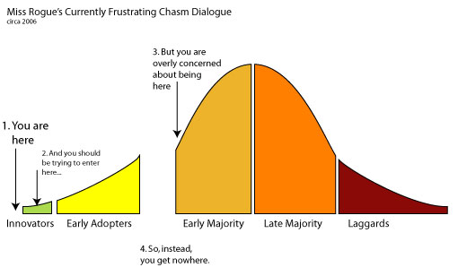

**Five groups of consumers**

* **Innovators** – had larger ventures, were more educated, more prosperous and more risk-oriented
* **Early adopters** – younger, more educated, tended to be community leaders, less prosperous
* **Early majority** – more conservative but open to new ideas, active in community and influence to neighbours
* **Late majority** – older, less educated, fairly conservative and less socially active
* **Laggards** – very conservative, had small ventures and capital, oldest and least educated

**Challenges faced between 5 groups**

* **Innovators/Early Adopters** - Often, what works for early adopters does not work for the mainstream and the other way around. Early adopters are typically techies, they want power tools; they eat, sleep, and drink tech; they are spoiled.
* **Mainstream** - users are techophobic; they need one button at most; they freak out when things change. For this reason if a startup aims at the mainstream right away, the chances are it won't even get to the chasm.

**What is meant by crossing the chasm?**

Moore argued that there is a gap that exists between the early adopters of any technology and the mass market.

Many technologies initially get pulled into the market by enthusiasts, but later fail to get wider adoption

Early adopters represent a very small percentage of the population; the thinking is that you can't build a business just by selling to them. To build a real business you need to cross the chasm.

**Example: The IPod Crossing the Chasm**

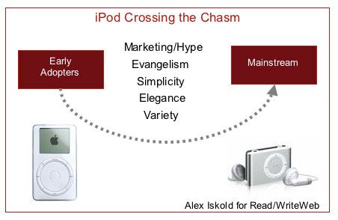

It took a combination of the well-oiled Apple marketing machine, a beautiful product and a passionate user base. Apple marketing made iPods into objects of desire, envy and fashion. Apple's engineering team iterated through many versions of the product, with each getting better and simpler, yet more powerful than the previous. But what really made iPod into such a phenomenon is that it spread virally. iPod owners love their iPods and talk about them all the time. The early adopters of this product became an army of evangelists.

**Crossing the chasm – High school dance problem**

**Adoption of disruptive innovation**

* The rest of the world isn’t ready for you!
* How do you get the dance started!

Most **people are pragmatic** & Want to see things **tested and demonstrated**, look to others

**Key: Look for customers in pain**

**Looking for a potential segment of customers in pain**

* Standard legacy solutions are unsuited to their problems. Open to something new and willing to pay a price for it.

**Stop the bleeding pricing**

Sell to that customer & deliver the goods

* Already **spending a lot of money** on a solution that doesn’t **quite fit the bill**.
* If they move to your solution, they **solve the pain** and may even have **money left over**.

**Bowling pin effect! – Other customers in vertical market**

There are other customers in the same **vertical market**, when you knock **down the first customers, the rest follow**.

* They **introduce** you to other **people in segment.**
* They say it works for us but you can’t just move on through customers, you need to stay in the market long enough for people to say – “**This is the way to solve that problem**”.

At that point all the remaining **customers come to you** :

* cost of sales goes to zero,
* Negations power goes through the roof.

**Quotes -** **Geoffrey Moore**

In technology products, there is this very interesting phenomena of the psychology of the technology enthusiast.

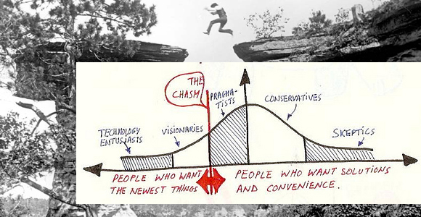

**Challenges of crossing the chasm**

* The rush of **early adopters slows down** and **sales getting tougher**
* Proving **sales are data points** on trend.
* challenge is in **convincing early majority( pragmatists)**, to **choose your product**

**How to cross the chasm**

* **Focus on answering “Why”, before saying what the product does**. E.g. Apple

**The Market**

**What is the Market – Pain + Money = Selling Target**

A group of customers who:

* Have the same pain , Money, Talk to each other

**What is Price – Value , Margin, Context**

* **Price of something is what someone will pay for it.**
* Pricing Factors: Value, Margin, Context = Price
* **Value**(Customers perceived worth of product)
* **Margin**(Rate of profit)
* **Context**(Everything else)

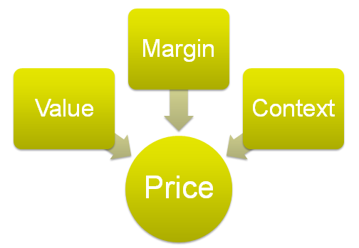

**Margin – How the P/L Works**

Price must support healthy margins

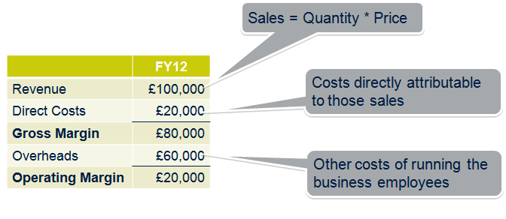

**Profit Loss - P/L = Profit/Loss**

* Revenue - Direct Costs = **Gross Margin**
* Gross margin - Overheads = **Operating Margin**

**Value : Economics, Utility, Risk, Cachet**

* Hard to measure
* Subjective
* Proprietary
* Rarely Administrable
* Worth thinking through

**Context:**

**Tell the market what it wants**. Put yourself in their shoes, **speak their language**

* Proportionate cost of each element in the “system”
* Competitors collectively set price expectations
* New entrants often severely undercut prices
* Some markets maintain high margins
* Maturing markets get commoditised

**Indirect channels**

* Pricing to customers should be channel agnostic
* Partners need 30-50% resale margin
* -Minimum operable gross margins for partners -10%
* Lower internal costs of employees doing sales
* **Higher marketing costs** – drive demand for partners
* Indirect often for volume and reach in SMB.

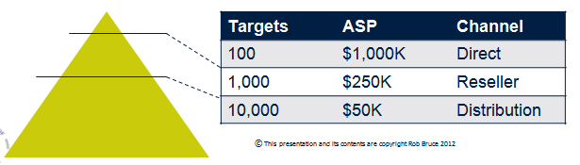

**Market Maturity**

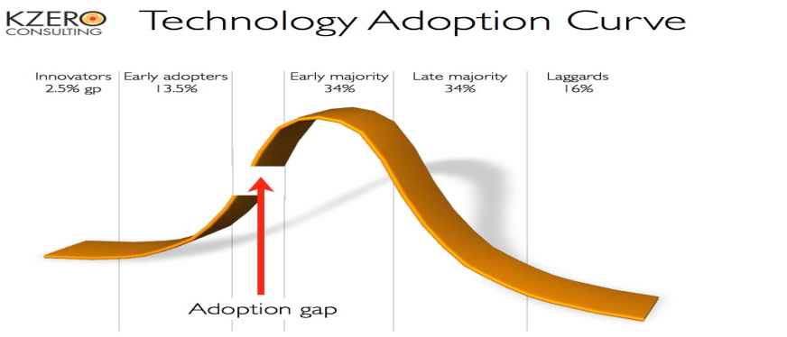

**Summary of Market**

* **Price is what market will pay**
* Price must **support healthy margins**
* Complexity, segment, & channel affect margin
* Value is not just about business case
* Price should reflect value & be administrable
* Market context and maturity affects price

**Market Intelligence**

If you don’t understand the market and what it thinks it needs, you’re offering guesswork. **Go Find Out!**

**People Buy Value**

* The market only buys stuff that will create a benefit (Money, make/save it)

**Value proposition**: The wrapper used to bundle the firm’s offering to the market

**Rules of Market Intelligence**

1. Tell the market what it wants to hear – Product and positioning must fit the market
2. People buy value - The market only buys products that save money, make money or deliver an intangible benefit

The value proposition – the wrapper used to bundle the firm’s offering to the market

**What is a market problem?**

A **Pain** and a **opportunity**

**Product Marketing**

Product marketing is about communication, getting the **right message out and creating demand**

**Product marketer**

Product marketer is there to help create demand

**Road Map**

* plan for a year ahead, used to measure goals, progress
* Validate assumptions with the market

**Market Research Document**

Minimum MRD

* Intro
* The market
* Current Product
* Product Definition
* Delivery Mode
* Acceptance Crit for product release to customers
* Channel/Partner support
* Pricing and packaging
* Schedules

**Define the roles of Product / Project Manager**

**Product Manager**

A  Product Managers is responsible for the ongoing satisfaction of unmet needs of customers so it will contribute to the following:

* **More value than the competition**
* **Build a sustainable competitive advantage**
* **Financial benefit for a business**

This includes but also extends beyond the lifecycle of any one product. Managing the product throughout the product lifecycle ensuring that it continues to satisfy market needs includes:

* **Gathering and prioritising** product and customer requirements,
* **Defining the product vision**,
* **Working** closely **with engineering**,
* **Working with sales**, **marketing** and **support** to ensure **revenue and customer satisfaction** goals are met.

The Product Manager’s job also includes ensuring that the product and marketing efforts support the company’s overall strategy and goals. A Product Manager tries to find out the customers’ needs and develop a product to satisfy them.

**Project Manager**

A Project Manager is ultimately responsible for a predefined outcome which will be described as the projects objective. They will manage the development of the product, service or result through the application of available resources (including a project team).

Project Management as a discipline provides the tools and techniques for the team to organise and prioritise the various tasks that need to be completed, as well as work within any applicable constraints (including time, cost, and quality). The tools and techniques Project Managers usually employ can be roughly divided into 3 main areas:

* **Risk and issue management** is an important aspect of Project Management and serves to highlight and then manage any risks to the project completing successfully, as well as minimising the impact of any issues that are identified.
* **Resource management** involves ensuring the project team have what they need, when they need it. That includes such simple things as task lists, materials, infrastructure, reporting and even extra people
* **Scope management** is usually the most difficult activity a Project Manager is involved in and involves limiting the extent (scope) of the endeavour within acceptable allowances, usually engaging in a balancing act between the three critical aspects of time, cost and quality. **For instance**, if the time to deliver the project is reduced then either cost must be increased, or scope reduced to maintain quality.

Project management is a tactical, time limited activity that is defined by the businesses strategic objectives.

**Role Overlap**

It’s evident that the roles of a Project Manager and a Product Manager are very different but these roles have a similar skill set.

* **Excellent organisational and interpersonal skills**
* **Leadership qualities**
* **Time management**

So it is not uncommon for organisations to ask Product Managers to take on Project Management responsibility and vice versa.

**Resulting Problems**

We see that doing both jobs can compromise the successful delivery of a project

* If a Product Manager is also running a project his/her **time and attention for the customer strategy gets diverted to chasing people, reporting** etc.
* You do not have the **sufficient skill set to perform well on all points**.
* A Project Manager **excels at managing to datelines**
* A Product Manager **knows what the customer wants** and keeps that in mind.

Wearing both hats with different objectives sometimes results in a conflict of interest.

**How Can We Manage These Problems?**

In some situations it may still be feasible to have the Product Manager also undertake the Project Management role. However it is always ideal to have these two roles done by two individuals. Depending on the following factors, it is good to recommend that both Project Manger and Product Manager roles will be carried out by two individuals to successfully complete a project and launch a good product:

* Large size project
* Multiple involved departments and stakeholders
* Longer delivery time line
* Multiple geographic  locations
* Big team (i.e. 5+ people to co-ordinate)

## “Product vs Project Manager Detector”

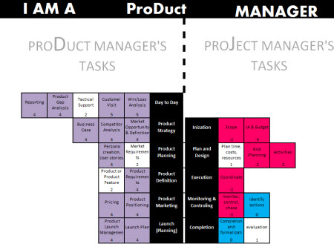

**Product / Project Management Quotes**

**Quote** - “A project manager’s role is very different from a product manager. Using the same person as product and project manager does justice to neither role.” - **Irene Liakos**

**Quote** - **“A Project Manager is like a mid wife- he/she delivers the baby, hands it over to the mother and moves on. The baby being the product and the mother being the Product Manager” - Derek Morrison**

**What are Product Management and Product Marketing, why do they matter and how do they relate to Engineering?**

**PM Principles & understanding What Your**

**Market Wants**

**Why do we do product management and product marketing ( PM&M)**

Formalises processes and gives them owners

* Without **Management** the product will be wrong
* Without **Marketing** exploits value in product.

Everyone is involved but

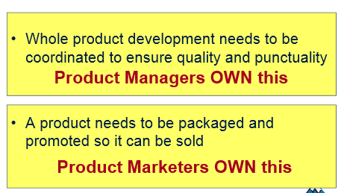

**Product Marketing – Five Key Components – Q3A**

* **Lead Generation** – direction and with channel
* **Public face** of the company
* **Deliver** **positioning** for company
* **Mediator/enforcer** of positioning

**Product Marketing Value**

* Consistent, focused messaging
* In line with market language / dynamics
* Collaborative marketing with partners
* Generates market awareness & interest (direct/indirect sales).

**Objections to Product Marketing**

* Cover by sales
* No resources – promotion is too expensive
* We know the market already
* Marketing never generates real leads.

**Product Management - Tasks**

* **Ensures** products **delivered on time** with **quality**.
* **Produced efficiently**
* Partners & customers are more **satisfied**

**Location of Product Manager**

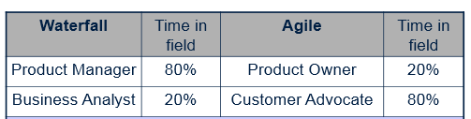

**Problems with Product Management in companies**

* No resources
* Methodology is time consuming
* Detailed technical descriptions are enough
* CEO,CTO,CMO has that job
* We know what to build already

**Product Marketing relates to Project Management**

* **They share the objective – success in the market**
* **Share much of the same data** – client, market information, intelligence
* **Use many of same soruces** of research and verification, clients, firms, competitors, and the market in general
* **Contribute to each other as information and intelligence sources** to help achieve the same objective.

**Product Management in an organisation**

Product Manager/Owner

* **is the owner of the product** on behalf of Executive Management
* is the customer of Engineering
* **uses Product - and Channel**
  + **Marketing to create the value proposition**, positioning, messaging and support required to
* **effectively sell his product**
* **uses channel (direct and indirect)** to get his product to market
* is **responsible to Executive Management** for life cycle decisions (birth, renewal and “death”) of product
* has P&L responsibility for the product life cycle (multiple years)

**Key influences on Product Management design**

* **Culture of market**
* **Development methodology**
* Product attributes
* Practical issues

**Balance risk taking**

* Run **experiments**
* **Minimal viable products**
* **Continuous deployment**
* Smart test coverage
* **Use of immune system**
* Post mortems, and retrospectives % 5 Why’s

**Continuous Innovation**

Validate Hypotheses with Data

**Immune systems**

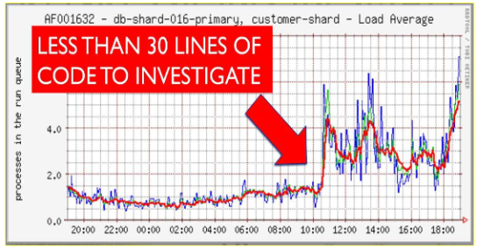

**Small change-sets = easy debugging**

**Approaches to Product Release**

* Measure against pre-defined **release criteria**
* **Date driven** ( content dropped if necessary)
* **Content Driven** ( date allowed to slip is necessary)
* **Hybrid**( content dropped & date allowed to slip

**Markets – Releasing products**

**Mature** Metrics **available and valid**

**MRD** a fairly **static** document

**Nascent** Metrics **unavailable or invalid**

Initial MRD is a **guesstimate**

**Best Release tempo**

* **Hardware** – 2 years
* **Enterprise** – Saap – Annual
* **Saas** – 1-2 weeks / month
* **Extreme** – IMVU – 7 Minutes

**Requirements / Sub Requirements**

* **Priority** – MRD
* **Low hanging fruit** – Relatively easy
* **Complex** – varies from difficult to complex
* **Needs technology** – requires IP to be created, licensed, etc
* **Dependencies** – dependant on another requirement.

**Selection Criteria for requirements**

Must always be a business reason to set a product priority

* **Makes sales**
* **Retain customers**
* **Expand** the addressable **market**
* Enter **new vertical market** sector
* **Stabilise the product**

**Requirement Opacity**

Granularity verses deadlines: It’s ok not to have the nth degree of detail of what you’re going to build in 6 months.

**Requirements Gathering Process**

* To understand the key processes run by the Product Manager
  + Externally to capture requirements
  + Internally with colleagues
* Understand the differences between managing cloud-based and on-premise installed products

**Requirements gathering – Describe and Identify**

**Interviews**

* Semi-structured interview
* Advantages
* Disadvantages

**Gather Requirements Externally**

* **Surveys**
* **Customer Interview**
* **Industry Sources and Analysts**
* **Standards/Seminars**

**What is the nature of the key requirements you need to establish?**

* Not functionality of product. Features + what it will do, **key selling points**?
* **Perspective from people** above and below product manager in company.
* What the **project manager does** in their day-to-day, how do they do it?
* What **problems do they encounter**, how do they currently solve the problems? What would be an ideal way of solving the same problems
* Formed in a way that would **relate to product manager.**

**From where will you gather your requirements other than the product managers who have agreed to help?**

* **Perspective from people** above and below product manager in company.
* **Other software** that provides similar functionality, what works? What doesn't work?
* **Influential people in the field**. Experts, past + current.

**How are you going to establish the size of the market?**

* **Find Similar businesses** that have the potential to encounter the same problems
* **Establish common ground between business** that need product
* **Businesses using similar software** - how can you make it better? Can you turn them to your own software instead?
* **ANALYSTS**

**Modes of Software Delivery**

**Software as a Service**

* **Client does not get to choose** where to run it.
* **Signup for service**,& start consuming via Internet
* Companies **save money** and can focus on what they do best e.g. **specialised SaaS**
* **No upfront investment** – changeable.
* **Public cloud**
* **Multi-tenanted cloud** - Salesforce.com , Skype, eBay
* **Single tenanted hosted**
* **Internally hosted**- Can be multi-site (RBS, Government)

**SaaS Lifecycle – Minutes to months lifecycle**

* + **Continuous** Beta, drip feed releases
  + **Little partners, training, sales support**

**Example of SaaS**

* **Single tenant** (remotely hosted)- big, conservative banks
* **Multi-tenant** (cloud) SaaS - For individual hotel owners

**Advantages of Saas**

* **Flattens investment** cost & recenue growth
* **Simple pricing metrics** ( user/month)
* **Editions** – package functionality

**Software as a Product – SaaP – Licensing Model**

* **Traditional** way in which companies made money.
* Develop software, and **buy license** to use it.
* **Client/server executable**
* **Device based executable apps** 
  + Oracle Applications (both)
  + MS Office (both)
  + SAP - Windows, Mac OS, Xbox, Playstation

**SAAP – 12-24+ Month lifecycle**

* **Full product cycle and release**
* **Full partner, sales support**
* Hardware has these timeframes due to manufacturing lead times

**Open Source**

* “**free**” but costs to manage the software.
* Optionally you can opt in to receive support

**Internet Model**

* **Advertisements**. Internet services like Facebook, Google, Gmail, etc rely on advertisement
* **Cost of software is not charged** from the user

**Freemium e.g. Dropbox**

* **Try before you buy**
* Paying **customers fund services for all**
* **Function thresholds** / price points segment market
* Positive **word of mouth** is pivotal

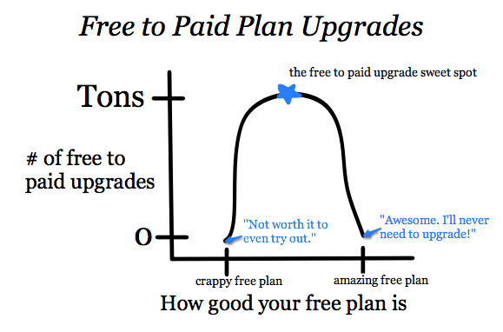

**Market Strategy and Analysis**

SAAS just implemented quicker

* + - **More prototyping** in MRD
    - Start with Minimum Viable Product **(MVP) and grow**
    - **Train timetable release**

Interested parities compete for seats (ebay)

* + - * **Sprint release** (1 month), “complete” release a quarter
    - Includes infrastructure (24x7, Online support, training)
    - **Little channel support**

**Minimum Viable Product**

* Contains just enough features so it can be **deployed to validate it’s market**
* **Release early, release often**

**Examples**

* First apple iphone has no cust & pasta
* First realese of g-mail written in a day
* First facebook picture handling added by summer intern, now 100s million pictures added a day.

**Approach to Minimum viable product**

* Test Driven Development
* Down-sizing requirements
* Atomisation
* Sprints

**AARRR**

* **Acquisition** – User is directed to your site;
* **Activation** – User signs up or is otherwise engaged;
* **Retention** – User keeps coming back-engaged overtime
* **Referral** – User invites others;
* **Revenue** – User pays or is otherwise monetized

**Product Definition & Case – Enforces Golden Rule**

**Three Activities**

* Gather requirements
* Present requirements through MRD, Themes, User Stories
* Negotiate requirements.

**Leads to “go/no go” on build & launch**

**Product Definition Group**

* Company focus for product decisions
* Chaired by product management
* All perspective represented
* Agrees priorities for this product release

**Product Definition Group and Case Stage**

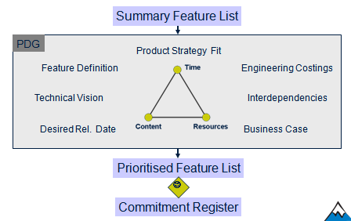

* Meets as necessary (every 2 days, 2 weeks, 2 months)
* Documented and minutes by product manager
* PDG Process for giving a release

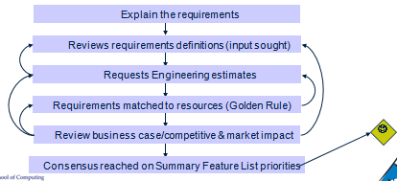

**Commitment Register**

* Committed-to list of features for release
* References updated MRD
* Published on Intranet
* Chiefly for engineering(internal)
* Only changed with PDG approval.

**THE DEFINITIVE list of what is going to be built and when**

**Product Roadmaps**

**Internal product roadmap**

* Bullet list of release features and time scale
* Published on the intranet
* External used banned

**External Product Roadmap**

* Subset list of features
* Timescales significantly hedged

Partners may be brief beyond external.

**Reprise**

* Negotiation finalises the real product
* Golden rule is vital
* The PDC enforces the Golden Rule and ensure most appropriate product built

**Advantages of gathering requirements**

* Makes products are that are market led
* Definition definition of solution to market problem
* Find middle ground across customer needs.

**Business Case(Why invest) / User Stories**

* Describes business function required
* Describes how users would use it
* Simply delivery by index cards, demo then collected into themes.

**Example**: Want to pay for something via PayPal.

**Market Requirements Document – Internal Document**

**Value provided** as

* Market problem definition
* Key gathered requirements
* Product business case( Why invest)

**Used to**

* Reference document for engineering
* Prototyping scenarios (Customers & Users)
* Basic for MRD summary feature list.

**A MRD should be**

* 1 MRD per major release
* Tens of pages
* Illustrated with practical examples

**Themes**

**Product Life Cycle**

**Purpose of a product life cycle**

Why do we need a repeatable product lifecycle?

It’s more efficient

* Everybody knows **what comes next**
* If things go wrong changes **can be made easily**
* **Personnel change**s can be tolerated
* Products get **released on time**
* **Quality improves**

It improves customer satisfaction

*“Products you build should be products your market wants. - How do you find out what it wants? Ask people in it!”*

**The Mantra - Quote**

**Quote** - “The product and channel have to be built around the market problem and the way the market wants to buy”

**Define the term Market – A group of customers who :**

Have **the same pain**, Have **money**, & **Talk to each other**

**Structuring for sustained growth**

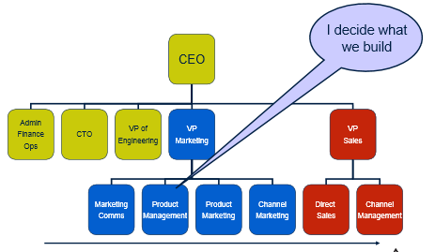

**Definitions of methodologies and deployment**

**Waterfall** Enterprise Every 6-12 months

**Agile** Enterprise Every 1-3 weeks

Consumer (Lean)

**Continuous** **deployment** daily

**IMVU** every 7 minutes

**Waterfall Product Process Summary**

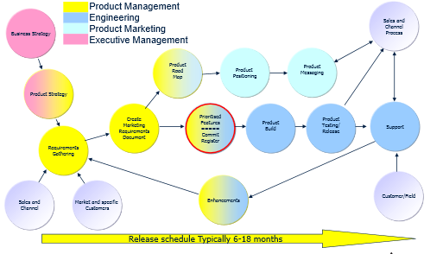

**Agile Enterprise product process Summary**

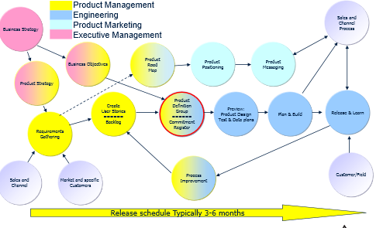

**Agile consumer product process summary**

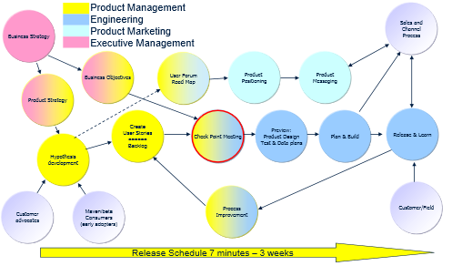

**Lean Methodology**

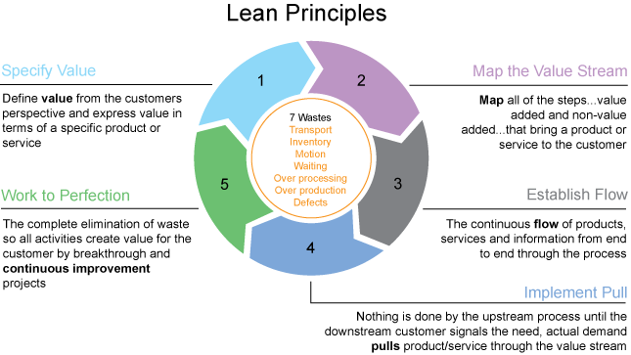

1. **Specify Value** from Customers
2. **Map the value stream** ( value added – non value added)
3. **Establish flow** – continuous information flow through iterations
4. **Implement Pull** – downstream customers signal the need
5. **Work to perfection** – eliminate waste and generate value for the customer – continuous improvements.

**Strategy First**

* Management concerned with developing the most **appropriate products for its target market**
* **Business first** then product
* **Identifies potential markets**.

**Requirements capture**

* Detailed definition of market needs
* **Waterfall** – Interview, requirements, write MRD
* **Agile/L**, scenarios, prototype, feedback, and repeat.

**Prioritisation**

* Select and coordinate the order in which functionality is build
* Manage product direction resulting from business or technical changes
* Success criteria.

**Ensures** : Product build with quality, appropriate design, relevance to market needs ( customer & partners).

**Define the term Channel**

Importance in relation to Technology Innovation

**Product strategy**

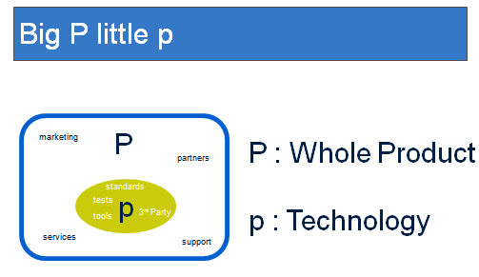**Big P Little p**

* **Big P**

Whole Product

* **Little p**

Technology

**Stages of a products life cycle**

1. **INTRODUCTION** 
   * Low and slow stage: The product sales are the lowest and move up very slowly at snail's pace
   * Highest promotional Stage: During this period of introduction or the development, promotional expenses bear the highest proportion of sales."The product's costs rise sharply as the heavy expense of advertising and marketing any new product begins to take its toll."
   * Highest Product prices:Lower input and sales absorbing fixed costs.
2. **GROWTH**

Once the market has accepted the product,sales begin to rise.This is most crucial stage and help the brand to establish in the market.

1. **MATURITY**

Market becomes saturated because, the house hold demand is satisfied and distribution channels are full.By now the product is widely accepted and growth slows down. Before long, however, a successful product in this phase will come under pressure from competitors. The producer will have to start spending again in order to defend the product's market position.

1. **DECLINE**

Sooner or later actual sales begin to fall under the impact of new product competition and changing consumer tastes and preferences.

A company will no longer be able to fend off the competition, or a change in consumer tastes or lifestyle will render the product redundant. At this point the company has to decide how to bring the product's life to an end.

The product life cycle is an important concept in marketing. It includes four stages that a product goes through from when it was first thought of until it is eliminated from the industry. Not all products reach this final stage. Some continue to grow and others rise and fall.

**Customer vs User**

**Economic buyer** (customer)

* Revenue, reports, monitoring, cross selling

**User** (economic buyers customer)

* Easy of use, design, relevance and efficiency

**What are requirements? – Market Pain!**

Detailed definition of market “needs”

* What do you want the product to do
* NOT, how do you want the product to work
* Based on Product Strategy

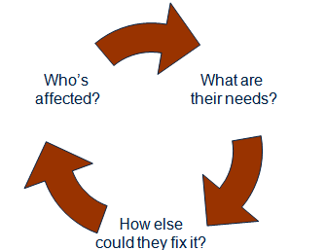**Scope of requirements**

Part of the market problem e.g. “I need my lawyers to not loose letter processing time while on the road”. Are we going to solve the:

* Workflow bit
* Connectivity bit
* Desktop bit
* Application integration bit
* Or some mix of the above bits?
* What **part of the “market problem**” we will set out to **solve (what needs)**
* What are the **alternative solutions** to this **part of the problem (how else)**
* The way it gets solved now - **Like competitors**
* What does our **ideal customer look like**? **(who affected)**

**Who is affected?**

**Who are the users?**

* Roles? Goals?
* Challenges? Blockages?
* Who are their customers? Economic & User.
* What do those customers care about?

**How important is the need to them**

* How much of their time does it take?
* Is this going to be a persistent need?
* How much of it are we likely to address?
* Who counts the economic benefit of fixing?

**What are their needs? - Define the problem**

* What’s the business process? What’s your workflow?
* What are the input & outputs?
* What technical standards must you adhere to?
* What industry standards prevail?
* What do we build, what is open source?
* What other systems would need to be connected?
* How would characterise the problem?
* What are the sticking points?
* In an ideal world – how would it work?
* If you could …would that be better?
* How much better?

**How else could they fix it ?**

**Define competition**

* Have you looked at fixing this problem?
* How else might you fix it?
* What suppliers would be involved?
* What do they offer?
* What would be involved in making the change?

**Research alternatives**

* What categories are they in? Dynamics?
* How much is category each worth? What is their share?
* What is their strategy? Their business model? Price?
* What are the switch over costs/barriers to entry?

**Purpose of requirements**

**Prioritise requirements for relevant product given time/resources available**

* Final decision on Build & Launch
* Agree Commitment Register with Engineering
* So front-office knows what’s coming
* So front-office knows what to tell customers and partners about what’s coming
* Ensure timely release of product
* Ensure product address the CURRENT market needs
* Ensure employees/customer/partners know what and when

**Types of requirements**

* Update existing product
* Major port / paradigm shift
* New Product Introduction
* Architecture/plumbing/maintenance
* Bugs

**Gathering Methods**

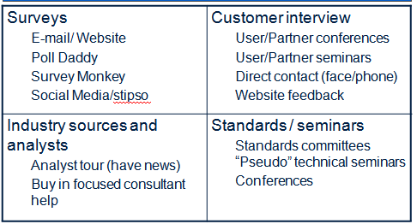

**Source of Requirements**

* **Customers -** Existing , Potential
* **Partners -** System integrators , ISVs
* **Market influencers -** Tech/industry bodies , Analysts, Blogs/Social Networks, Google
* **Company internal -** Management, Front office , CTO, Engineering, Systems
* **Advisory council**

**Source Matrix**

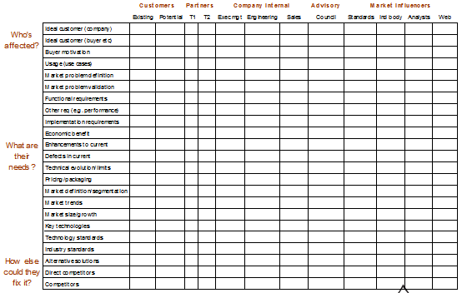

**Y Axis -** Whos affected, What are their needs, How else could they fix it ?

**X Axis – CPCAM -** Customer, Partners, company internals,advisory, market information

**Product Definition Group**

* Management
* Engineering
* Field
* Bug/Enhancement database
* Existing Customers
* Potential Customers
* Partners
* Advisor council
* Professional/Technical Bodies
* Industry Publications/Analysts
* Online search
* Reprise

**Who are internal?**

MEF(Be)(Ec)(Pc)(ac)(PB)A(OS)R

**Management**

* Strategic direction
* **Market/Problem Definition**
* Have Veto power so listen

**Engineering**

* Standards
* Open source
* **Technical parameters of possibility** (don’t always believe them!)
* Technical evolution

**Field**

* Support/technical/consulting/sales
* Often very short term/tactical view
* **Know problems which lead to sales**
* **Can identify practical/usability issues**
* Win/Loss analysis allows identifying product weaknesses

**Bug/Enhancement database**

* Logs product defects essential for QA
* Forum for internal/external product improvements suggestions
* **Part of Backlog**

**Existing Customers**

* Don’t be a “slave” to existing customers
* BUT must be kept happy and referencable
* **Good place to validate defined problems**
* Motivated to help as have existing investment (reputation/time)

**Potential Customers**

* Find companies in proposed markets to validate problem
* **Find companies in “sweet spot” of market**
* Find companies using competitive products and find out why using them

**Partners**

* **Business Model**
* Usability
* Packaging
* **Vertical Markets**
* Competitive

**Advisor council** - In absence of a product, give you credibility

* Small group of “luminaries”
* Meets once or twice per year
* Sounding board for company/ product futures
* **Provides credibility in marketplace**
* Valuable strategic input
  + Right river / where it’s going
  + Very important! - Especially early stage

**Professional/Technical Bodies**

* **Current/Future Standards Compliance**
* Open Source Forums
* Possibly attend conference. Normally to technical

**Industry Publications/Analysts**

* **Summations of trends**
* **Provide ROI stats/justification**
* Rarely visionary mostly reactionary
* Blogs/social networks now more used

**Online search**

* Always question source/motivation
* Dirt from discussion forums
* **Competitive Collateral**
* Template for documents
* **General background info on markets**

**Reprise**

* **Requirements gathering comes AFTER Business Strategy and Product Strategy are set**
* Requirements are business problems not features
* Requirements are for the market not for a customer

**What channels want?**

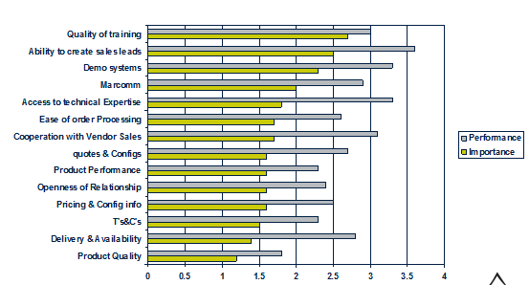

**DNA of positioning**

**Positioning statement** – Essentially an elevator pitch

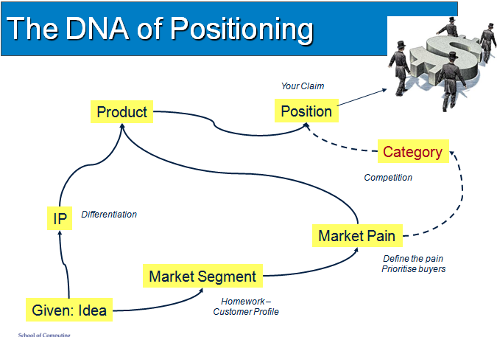

**Building an elevator Pitch**

For **[ name the target customer]** that **[ has this problem]** your product is a **[label it]** which **[ stake your claim].**

Unlike **[reference the competition]** your product can/has  **[ name the secret sauce ].**

**Four key benefits for VARs – cheap and quick**

* Deliver a higher level of service
* Cut your costs
* Boos recurring revenues
* Win more contacts

**Resource-Strapped Market**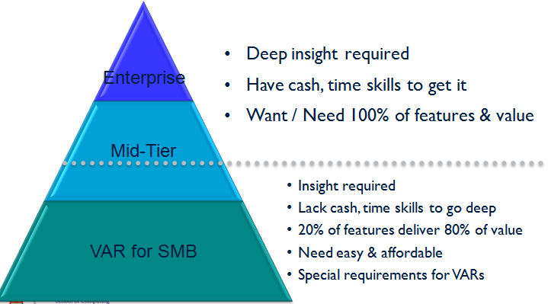

**Effective Propositions include**

* **Need creation** – frame the issues
* **Business Benefit**s – meet the need
* **Why me** – reasons to buy from you
* **How to buy** – where and how to purchase
* **Proof** – case studies and references
* **Appropriate Language** – use the market’s

**How Proposition Works**

* **Describes the company**
* **How it works**
* **How products** and services **benefits sector**

**Advantages of Proposition**

* Success in market rise
* Time to win first business shortens
* Position to lead and influence the market at a much earlier
* Sales pipeline should be healthier & easier topped up.

**Pull Technology**

Market pull is when **product ideas are produced in response to market forces**. Examples of market influences

* A **demand from consumers** for new or improved products.
* A **competing product** is launched by another manufacturer.
* A manufacturer wants to **increase market share** of

**Example:** Sometimes a designer will design a new or improved product simply because they believe that the very existence of the product will create market pull. Designs like this may succeed or fail, depending on consumer demand, how innovative the product is, and the state of the market

**Push Technology**

Technology push is **when products are re-designed because** of changes in materials or manufacturing methods. This might mean that new materials have become available, with improved properties; or that improvements in manufacturing processes mean a manufacturer can make the product cheaper or more efficiently, which reduces manufacturing costs.

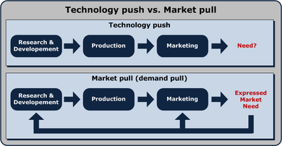

**Technology Transfer Definition of Technology Transfer**

The movement of new technology from its creator or researcher to a user, esp. as products or publications; also, the movement of new technology from developed areas to less-developed areas

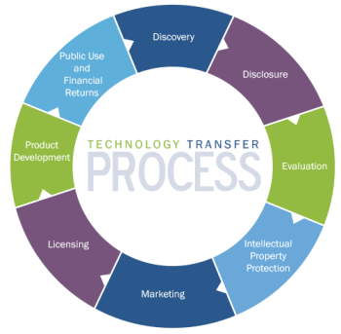

**Technology transfer – Primary focus**

1. Research
2. Commercialisation

**Bayh Dole Act of 1980**

* Significant piece of US legislation in the field of intellectual property
* Most developed countries now have a similar model with the UK adapting this model in 1986
* allows the **ownership of an invention to be pursued by the University irrespective** that the **funding the research was by the government** not the institution.

**Bringing technology to market**

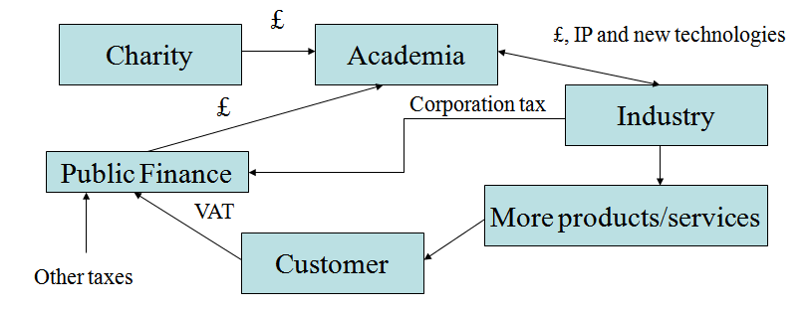

**Main Stages of Technology Transfer**

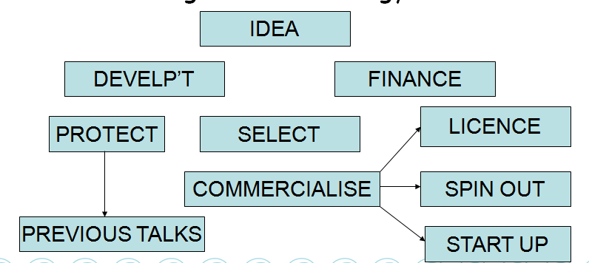

**Technology Transfer Stages and Finance**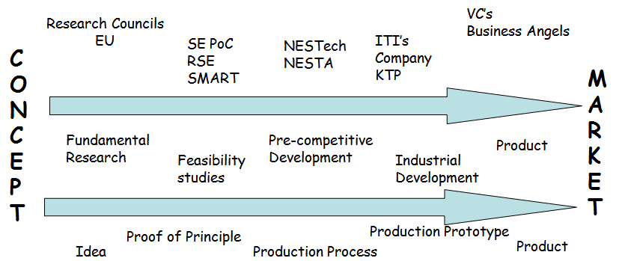

**Select – Example Due diligence requirement questions**

* Does the scientist want to **commercialise** their work?
* How strong is the **IP position**?
* Is additional *development* **funding** required?
* Is there a **market** for the technology?
* How strong is the **competition**?
* Is any **third party IP** required?
* Are there any future **legislation changes**?
* What is **the growth rate** of the market?

**Protect**

**Patent offers 20 year monopoly**

* UK application
* PCT (Patent Cooperation Treaty)
* and National phase
* Copyright more usual in the software world in the UK but patents are common in the USA.
* Other areas include trademarks and design rights

**Spin out company**

A spin out is based on **University owned Intellectual Property (IP) and driven by the University by actively seeking exploitation funding:**

* Equity shares based on risk and time to market inc. private funding
* Commercial expertise including business plan and Board of Directors
* Commercial Funding is very different from grant funding
* Assignation or Licence to the incorporated company

**Start up Company**

A start up differs from spin out as it is mainly **driven from outside the University**. A number of additional points are also relevant:

* More service orientated
* Networking with potential financiers of the business
* Networking with other like minded individuals i.e. University Greenhouse
* Access publicly available resources including the Business Gateway

**Licensing**

* A licence is granted to an **established commercial company or a university spin out company**
* Royalty payments is a return on this technology i.e. % based on revenue. This can vary greatly dependant on risk, licensee added value, sub licensees etc. based on achieving various milestones.
* The licence can be exclusive or non exclusive based on different territories or technical areas

**Potential private funding sources**

1. Family and Friends
2. High Street Banks
3. Business Angels
4. Venture Capital
5. Stock Markets including the Alternative Investment Market (AIM) – for early stage companies

**Technology Transfer Office at the University of Dundee   
with 30 staff (a similar model for all modern universities)**

* Business Development
* Licensing
* Intellectual Property
* Grants & Contracts
* Company Formation and support including incubators
  + Spin out
  + Start up
* Marketing

**Examples of Technology Transfer @ Dundee**

* QFT Ltd – Developing a novel technology for field emission displays. This is the same department that developed the TFT, the technological basis for the modern flat display market.
* STAR Dundee Ltd – Is a spin out from the computing department of UoD specialising in sales and development of SPACEWire, an onboard communication system for satellites and spacecraft.

**Due diligence**

**Types of IP**

* Patent
* Trademark
* Copyright
* Design rights/registered design
* Confidential know how

**What is due diligence?**

* Carrying out relevant checks
* **Investigating** and evaluate a business opportunity

*If it sounds too good to be true…… probably is.*

**Due Diligence is Risk Assessment**

* Identify any risks
  + Manage and plan for the risks
  + Finance the risks
  + In advance of specific opportunity
  + As a regular review

**Why would YOU do due diligence?**

Doing a deal with a commodity or property

* Doing a deal, for example
  + Prospective new employer
  + Buying a new car
  + Buying or selling a house
* Research Collaborations
* Buying, selling or licensing IP

**Benefits of due diligence**

* Managing expectations
* Freedom to operate and minimize risk of third party infringement
* Risk assessment and management
* Valuation of IP portfolio
* Negotiation tool

**Who does due diligence?**

In-house - IPR Managers, RIS, Inventors

External – Lawyers, Patent Agents, Third party reps

**The process or Stages of due diligence**

**Three stages of Due diligence**

* What is the IP
* Who owns the IP
* Ownership claims from 3rd parties – who funded it.

**Technology Transfer**

Definition: The movement of new technology from its creator to a user

* Teaching
* Research
* Conference presentation

**Stage 1: What is IP?**

Type of IP used and generated

* **Patent**
* **Trademark**
* **Copyright**
* **Software**
* **Domain name**

At what stage is the IP - remaining term of protection , territories, & how is it protected

**Stage 2: Who owns the IP?**

Who are the inventors?

Who owns the inventors IP?

* University employee – external funder
* External collaborator
* Student – undergraduate or post graduate

**Stage 3: Any third party claims?**

* Who funded the work
* Has anyone else’s material been used
* Has existing software been built upon
* Any other cross-licences

**Example 1 - Complete due diligence questionnaire**

* Name PI and co-applicants
* Details of employer
* Who pays the salary (UoD employer but funded by third party e.g. NHS)
* Detail all funding received by PI and team in the field
* Any data, material, software etc generated by the PI or team needed for the project (check terms of charity funding)
* Any data, material, software generated by a third party (check terms of MTA)
* Project outcomes

**Example 2**

* A team of undergraduate students is given a project . The aim of the project is to create software for a dating agency so that client details can be stored and matched to their ideal partner. The software also suggests the ideal date location.
* The team looks at existing systems and comes up with the software and calls it “It’s a Date. Com”. The team encounters problems along the way which are solved with the tutor. The front end of the software shows pictures and maps of the date location.
* The team sees a commercial opportunity and wants to seek venture funding to set up a company.

**Example 2 - Complete due diligence**

* What is IP associated with the project? – software, copyrights, trademarks, domain name, know -how
* Who owns the IP? – students, tutor, free ware/open source, Google maps, restaurants
* What is the state of the IP? – pending, territories
* Valuation of project……

**Example 2 - Value Project**

* State and success of competitors – better, faster
* Market size - is there room
* Software platform compatibility and longevity – lifespan, ease of use
* How secure is your IP – can you be out manoeuvred
* Access fee for clients – extra for a premium service
* Costs – legal fees for company formation/negotiation, IP protection, IP access, staff, accommodation, translation fees etc
* Route to market – start-up or licence to competitor

**Intellectual Property**

**Define Intellectual Property**

A set of laws the allow inventions and other creative works to be treated as items of property.

**Why is it difficult to define?**

An inventive step can be much more difficult to decide than novelty. A small difference can still be inventive. Most disputes over patents will probably be settled in court.

**Identify three ways in which IP can be Protected**

Patents, Copyright, trademarks – types of IP.

**Types of Intellectual Property**

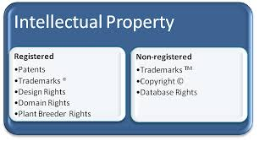

**Registered**

* Patents
* Registered designs
* Trademarks

**Unregistered**

* Copyright
* Design Right
* Know-how

**Sui-generis**

* Plant Variety Rights
* DB rights
* Semiconductor topologies

**Soft IP** – trademarks, copyright, design rights

**Hard IP** – others

**Patent Basics**

Protect the functional aspects of new inventions

* Territorial - only have effect in the country they’re filed in
* Normally last for 20 years
* Are a negative right - used to stop others using the invention

**Patents-Requirements**

* Novel
* Inventive
* Capable of industrial application
* Not prohibited

**Novelty**

“An invention shall be taken to be new if it does not form part of the state of the art”

* Any information disclosed to the public before the priority date of the patent - including the inventor’s own material
* Prior disclosure must unambiguously

**Inventive step**

* Much more difficult to decide than novelty
* A small difference can still be inventive
* Most disputes over patents will probably be settled in court

**Exclusions - Patents cannot be granted for**

* Scientific or mathematical discoveries
* Literary, dramatic, musical or artistic works
* Methods of performing a mental act, playing a game or doing business
* Methods for presenting information
* Certain computer programs

**Copyright- basics**

* Protects those works in all recorded media
* Lasts up to 70 years from the death of the creator

**Copyright - Idea vs Expression**

* Copyright only protects the expression of an idea, not the idea itself

**Copyright - Permitted Acts**

* Temporary copies for tech purposes
* Research and private studies
* Criticism, review and news
* Incidental inclusions
* Decompilation, observation and testing of software

**Copyright - Universal Licences**

* Copyright Licensing Agency
* Educational Recording Agency
* Ordnance Survey
* Newspaper Licensing Agency
* Public Screen License

**Designs - Basics**

* Protects the aesthetic features of articles for sale
* Do not protect design features dictated by technical features

**Designs - Requirements**

* Must convey a distinctive overall impression
* Designer’s freedom to design taken into account
* Judged against similar existing designs

**Trademarks -** Arguably the most important one

* Used by companies to distinguish their goods and services
* Can be extremely valuable
* Must be capable of visual representation
* Can be a word, logo, slogan, jingle or colour
* Must be distinctive and non descriptive
* Can last indefinitely but can also be revoked for non-use

**The golden triangle**

Key Concepts

There are 3 parameters that govern building products

* Time (Features x Resources)
* Content (Features)
* Resources (normally "fixed")
* **If you don’t do this quality will be the casualty**
* **Normally Time & Resources fixed**

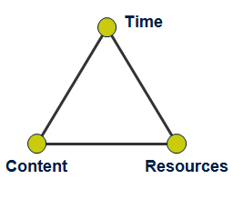A model of the constraints of [project management](http://en.wikipedia.org/wiki/Project_management). It is a graphic aid where the three attributes show on the corners of the triangle to show opposition. It is useful to help with intentionally choosing project biases, or analyzing the goals of a project.

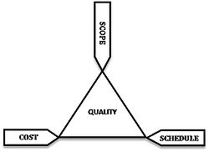

**Example : of Product Management Triangle**

* 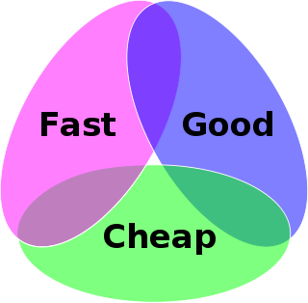Design something quickly and to a high standard, but then it will not be cheap.
* Design something quickly and cheaply, but it will not be of high quality.
* Design something with high quality and cheaply, but it will take a relatively long time.

**Brook’s Law**

**Adding manpower to a late software project makes it later**

* Fred Brooks, the mythical man-month

**“Nine women cannot have a baby in one month”.**

**Agile quote**

If I was the religious type I'd be nailing my protest to a cathedral door - but I didn't have time to validate 95 arguments with my user

**Agile for Enterprise**

* **Agile** – Development Methodology
* **Lean** – Business methodology

If engineering goes agile, product management goes BIG

Huge investment in

* People
* Infrastructure & testing
* Metrics & measurements

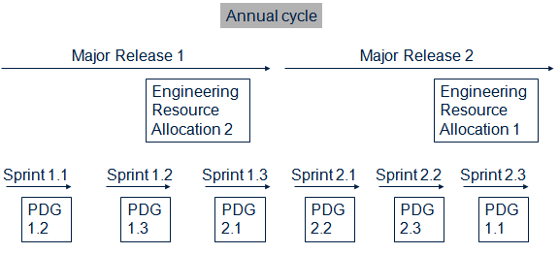

**Q3 Market Score Sheets**

A market score sheet is used to determine the position of the company both internally and externally.

User stories –

Large discrepancies between internal and external shows you don’t understand your market.

Internal – Engineering

External – Client

If something has a higher value than the internal score.

Product Manager Vs Sales Manager

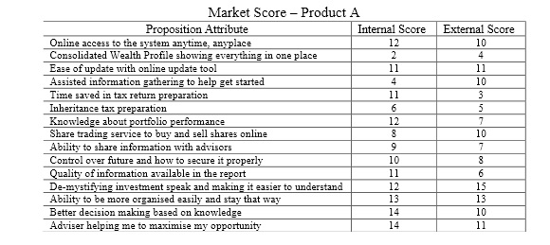

**Why is a market score sheet used?**

* Internal Score – What the developers think
* External Score – What the client thinks
* The difference – the gap in understanding

**What happens when a market score sheet is produced?**

* Reference to position

**Five key components of an effective Proposition**

**GO/No Go Statement**

* **Need creation** – frame the issues
* **Business Benefit**s – meet the need
* **Why me** – reasons to buy from you
* **How to buy** – where and how to purchase
* **Proof** – case studies and references

**All should be done with appropriate Language** – use the market’s

**Question 4 :**

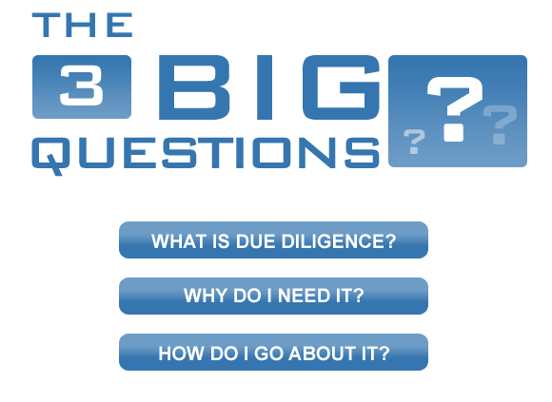

**What is due diligence?**

* "**Due diligence**" is a term used for an **investigation** of a business or person prior to signing a contract, or an act with a certain **standard of care**.
* The process through which a **potential acquirer evaluates** a target company or its assets for an **acquisition**.
* It **can be a legal obligation**, but the term will more **commonly apply to voluntary investigations**.

**Why is it important ?**

**Verify, Discover, Ensure Exists, Secure**

* **verify the information** provided is correct;
* **discover** any undisclosed problems.
* key trading contracts are in place; key employee employment contracts **exist**; and litigation exists or is threatened.
* Ensure IP is **securely** held

**Who should perform Due diligence?**

**Internal**

* Inventors,
* Internal Product Manager
* RIS

**External**

* Lawyers
* Patent Agents
* Third Party Reps

**What is Intellectual Property?**

Intellectual property (IP) refers to creations of the mind, such as inventions; literary and artistic works; designs; and symbols, names and images used in commerce.

**Three reasons why it is difficult define**

* Not all knowledge, innovation, and creation lends itself to the existing models. It may be widely recognised.
* Small innovations can be IP
* **What** is the IP, **Who** owns it, and **third party** claims.

**Importance of IP when approaching investors – Two examples**

Protecting your ideas and ensuring you can patent them.

* **What IP is associated with the project?** – software, copyrights, trademarks, domain name, know –how can all come from different source
* **Who owns the IP?** – students, tutor, free ware/open source, Google maps, restaurants
* **What is the state of the IP?** – pending, territories

**Q4 Case Studies**

Contrast two different approaches to managing the development and marketing of innovative technology.

* Discuss to technology innovation case studies,
* Describe their management approaches and highlight the difference between them
* Reference how the company is structured
* How new opportunities are identified
* How these are funded
* How innovation is managed

**Question 1** – essay like

* what have you learned about product management

**Question 2** – Think about last year’s HCI

* Company structures
* Roles
* MANTR
* how an MRD is formed.

**Question 3** –

* Score sheet
* Statistics
* Essay like again probably.
* Relevance of the score sheet.

**Market Score Sheet**

Used to see if you understand the market, a closer match the better

* Internal = Developers
* External = Stakeholders
* Scores based on importance

**Question 4** - Based on lectures,

* research, definitions
* legal issues
* IPs (intellectual properties
* due diligence(company level risk analysis)
* risk analysis

**Question 4(c)** –

* About our understanding of product management